ZOOM Education Guide
- How to sign up for the first time
- Start by going to zoom.us or clicking on https://zoom.us/ .
- On the top right corner, click on the blue “Sign Up, It’s Free” button (see Image 1).
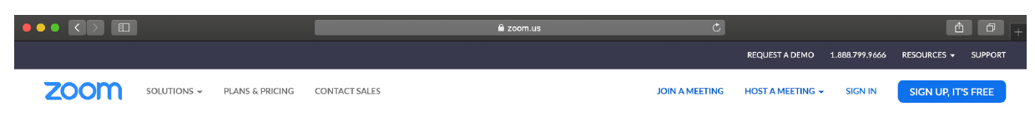
Image 1

- Enter your university email address ending in “@beykent.edu.tr” and click “Sign Up” (see Image 2). You can find your university e-mail on your student ID.
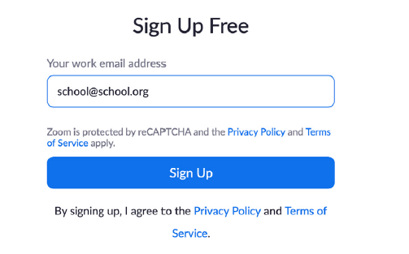
Image 2
- You will receive an e-mail from Zoom to activate. Go to your e-mail and click ‘Activate Account’ (see Image 3).

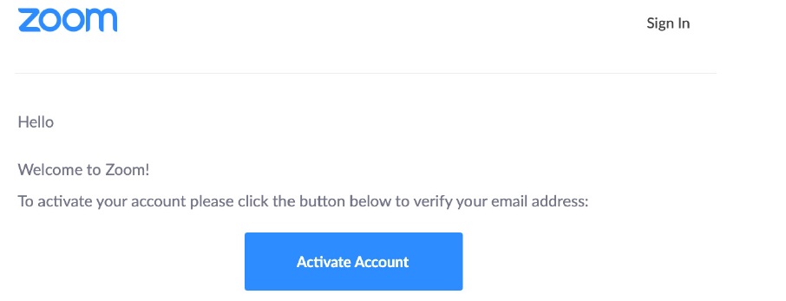
Image 3
- You will be redirected to fill in your first name, last name, and create a password (see Image 4). Then click “Continue” to go to the next step.

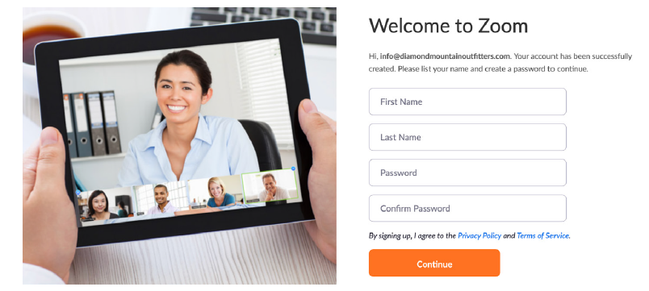
Image 4

- You will see the screen on Image 5. Select “Skip this step” to continue at the right bottom.
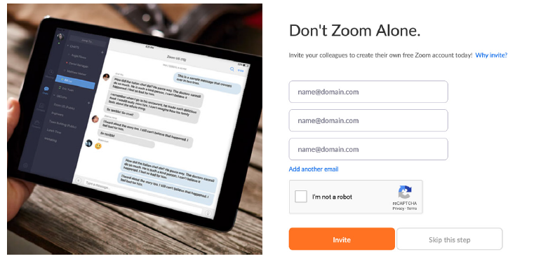
Image 5

- Following all the previous steps, you have successfully created a Zoom account. You can sign in by using the e-mail address and the password you registered with.

2. How to download the application
- Start by going to https://zoom.us/download.
- Click the blue “Download” button under Zoom Client for Meetings to access the installer (as shown in Image 6).

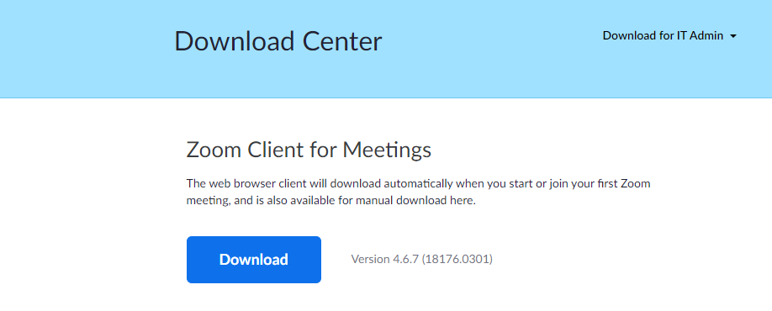
Image 6

- Open the Zoom installer from your Downloads folder and follow the on-screen steps to complete the installation.

3. How to join a class
- Find your class and your name in the class lists uploaded to the official website of the university. On the right column of those lists you can find the name of your instructors and their course codes. Your daily schedule will be the same, meaning the class hours of your instructors will be the same on every weekday. You need to sign in with the first code assigned to your class for the first two hours and with the second code for the last two hours of your lessons. You need to copy the codes of your lessons from those lists (for example, if you are a student in Step 1-01 class, you need to copy the code framed red for the first two hours, see image 7).

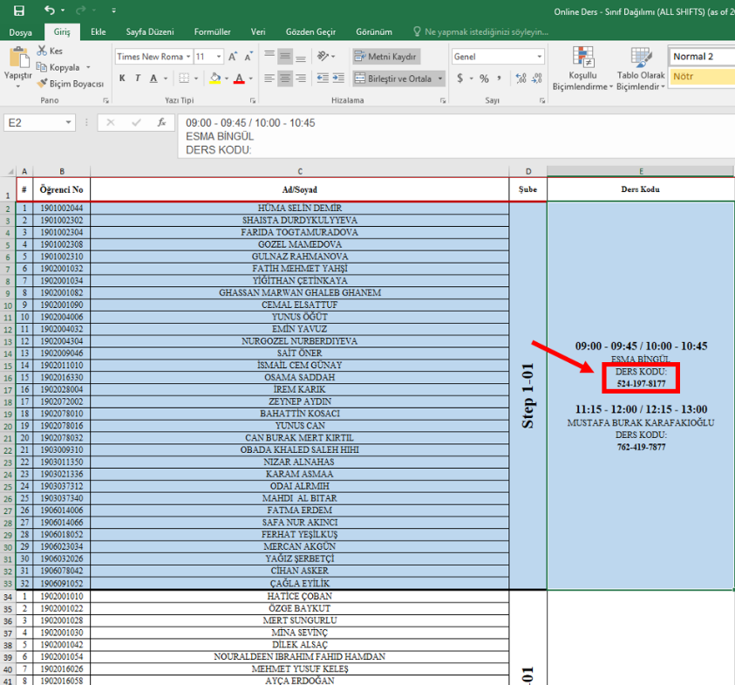

Image 7

- Click the “Join” tab on the home page of the application (see Image 8); this way you will be directed to the page where you can write the code you copied. On that page, paste the code in the box labelled “Enter meeting ID or personal link name” and click “Join” button (see Image 9). Then you will be directed to your class.

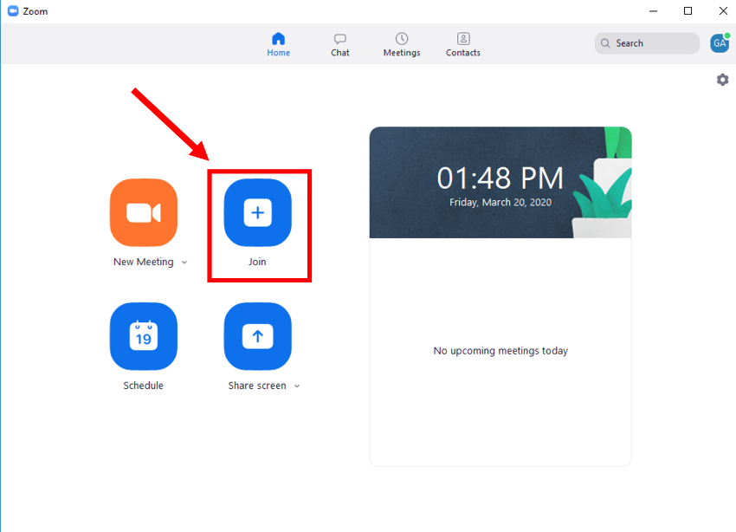

Image 8

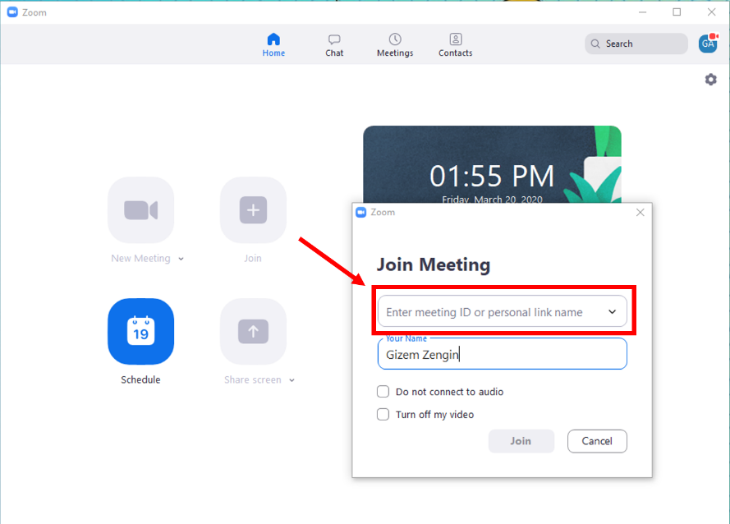

Image 9

- You need to use computer audio or phone audio to participate in your lessons.

