ZOOM Guide
- How to sign up for the first time
- Start by going to zoom.us or clicking on https://zoom.us/ .
- On the top right corner, click on the blue “Sign Up, It’s Free” button (see Image 1).
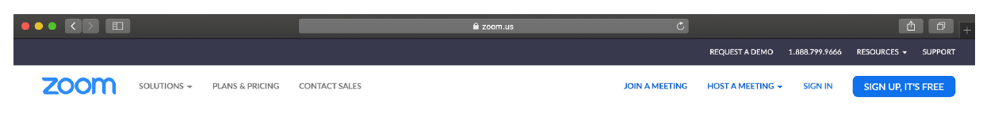
Image 1

- Enter your university email address ending in “@beykent.edu.tr” and click “Sign Up” (see Image 2). You can find your university e-mail on your student ID.
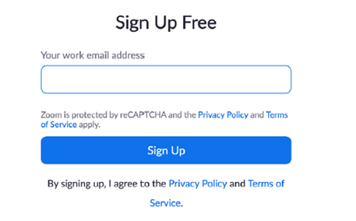
Image 2
- You will receive an e-mail from Zoom to activate. Go to your e-mail and click ‘Activate Account’ (see Image 3).

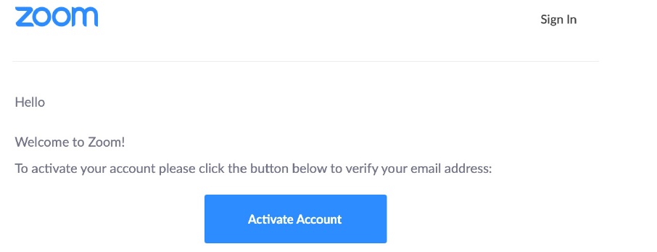
Image 3
- You will be redirected to fill in your first name, last name, and create a password (see Image 4). Then click “Continue” to go to the next step.

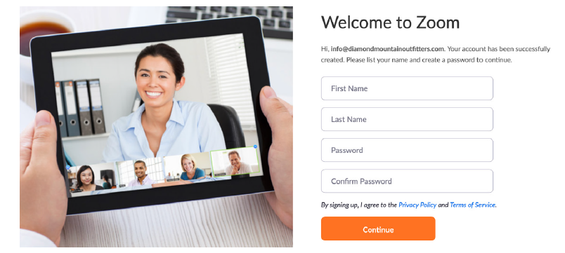
Image 4

- You will see the screen on Image 5. Select “Skip this step” to continue at the right bottom.
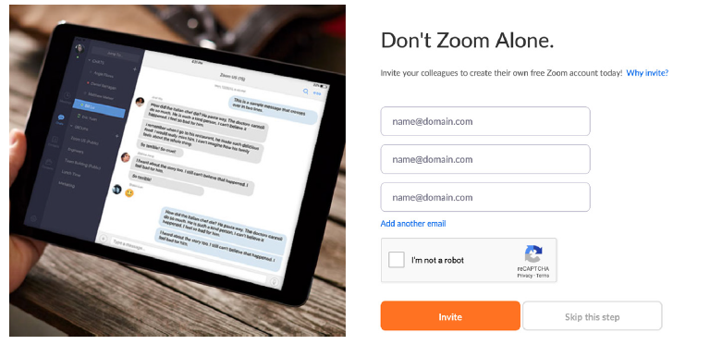
Image 5

- Following all the previous steps, you have successfully created a Zoom account. You can sign in by using the e-mail address and the password you registered with.

2. How to download the application
- Start by going to https://zoom.us/download.
- Click the blue “Download” button under Zoom Client for Meetings to access the installer (as shown in Image 6).

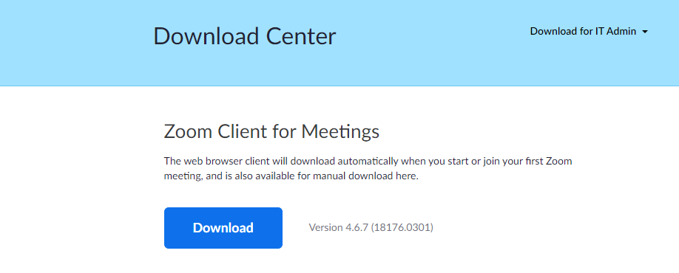
Image 6

- Open the Zoom installer from your Downloads folder and follow the on-screen steps to complete the installation.
3. How to join your ERASMUS+ SPEAKING EXAM CLASS:
- The Zoom code for your exam class will be sent to your Beykent University Student e-mail address. Please copy the Zoom code. If there is any passcode given, you should also note it down.
- Click the “Join” tab on the home page of the application (see Image 7); this way you will be directed to the page where you can write the Zoom code you copied. On that page, paste the Zoom code in the box labelled “Enter meeting ID or personal link name” and click “Join” button (see Image 8). If it is asked for, you should also enter the passcode after you paste the Zoom code. Then you will be directed to your exam class.
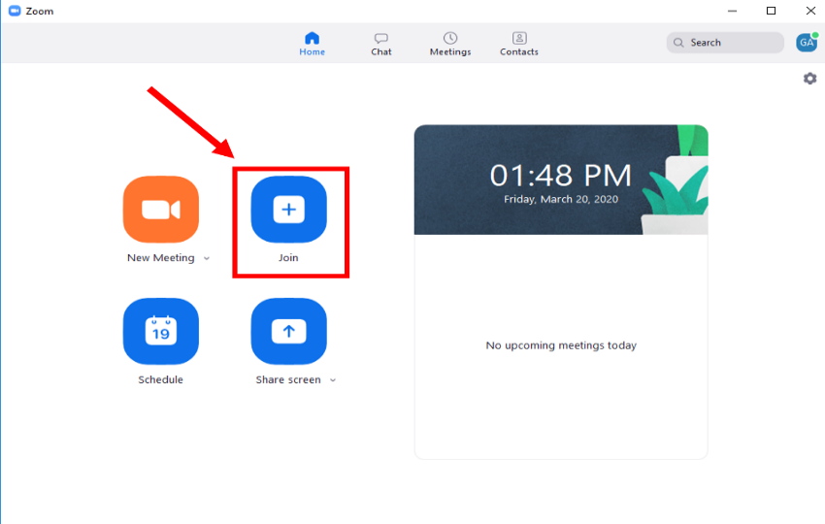

Image 7

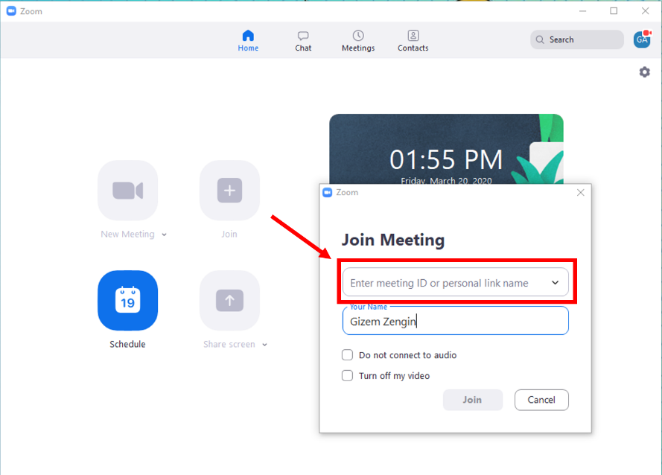

Image 8

- You need to use computer audio or phone audio to participate in the ERASMUS+ SPEAKING EXAM

